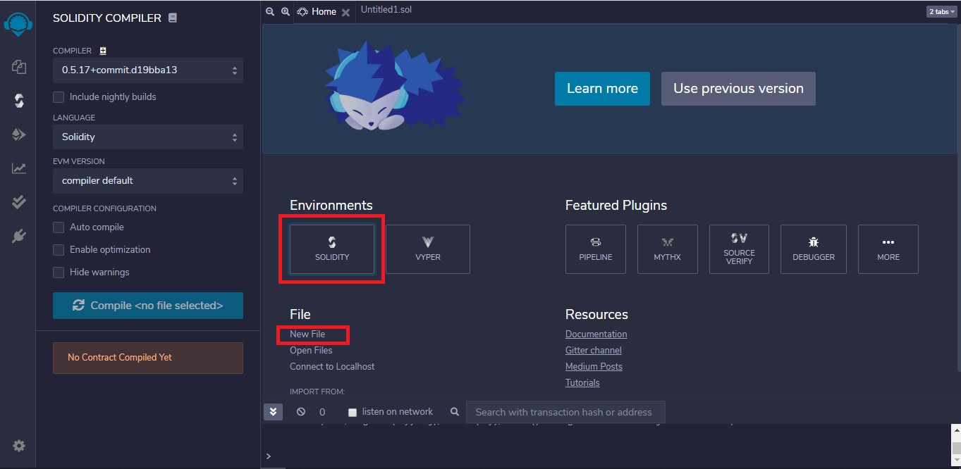
Assignment No. 4

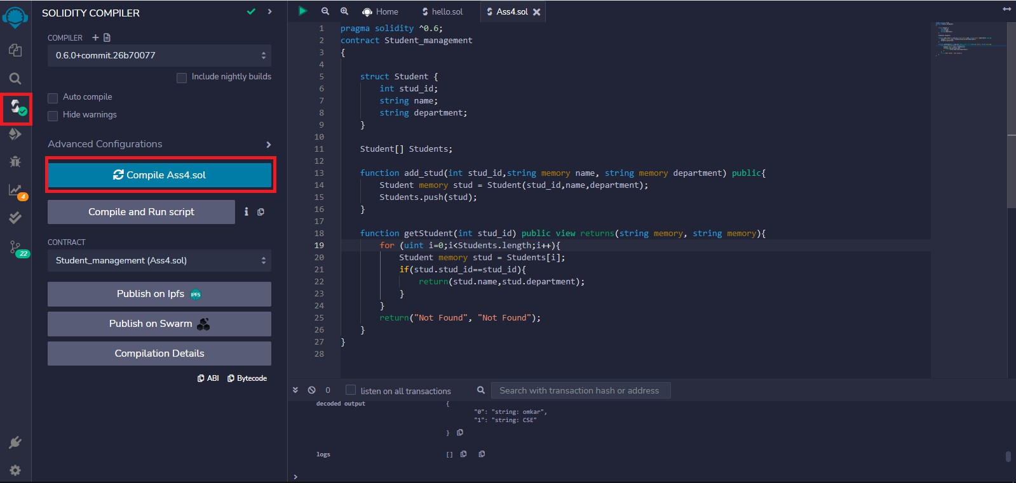

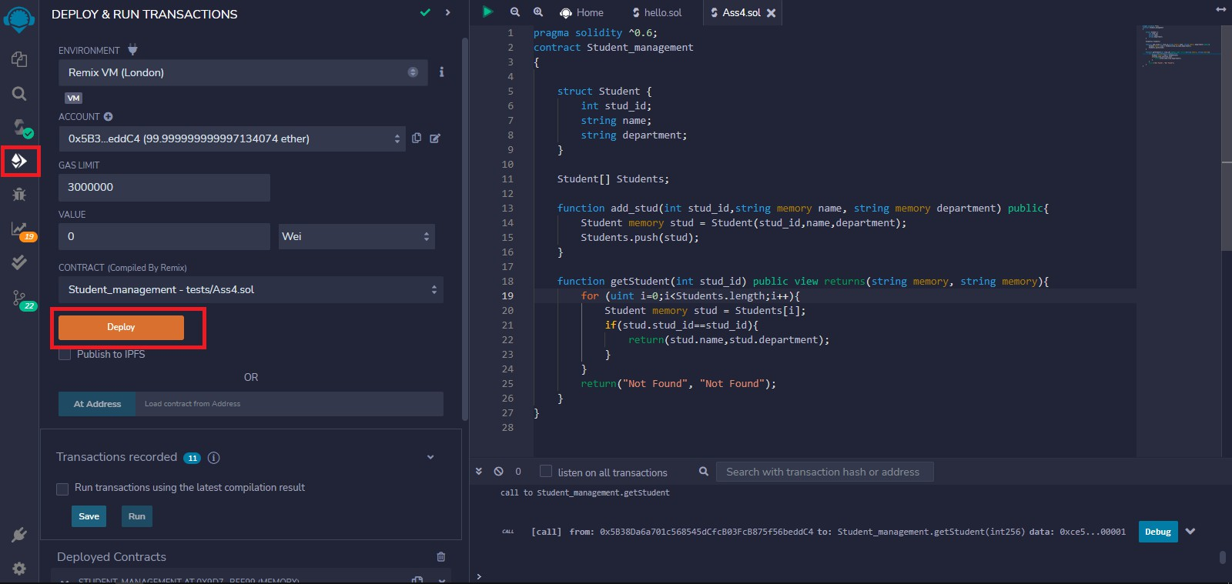

Code:
Pragma solidity ^0.6;
contract Student_management
{
struct Student { intstud_id;
string name; string department;
}
Student[] Students;
function add_stud(intstud_id,string memory name, string memory department) public{ Student memory stud = Student(stud_id,name,department);
Students.push(stud);
}
function getStudent(intstud_id) public view returns(string memory, string memory){ for (uinti=0;i<Students.length;i++){
Student memory stud = Students[i]; if(stud.stud_id==stud_id){
return(stud.name,stud.department);
}
}
return("Not Found", "Not Found");
}


